
CAUTION
Authorized Personnel Only
Command: ASC |  | Building: G55 | Room#: PAINT SHOP |  |  | Date: 25/02/2025
PRIMARY TASKS |  |  |  | TASK REQUIREMENTS




Task #1: Spray finishing






Task #2: Sanding





Task #3: Applying resin/epoxy

CHEMICAL HAZARDS |  |  |  | OTHER HAZARDS
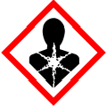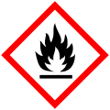 |  |  |  |     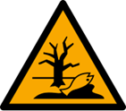  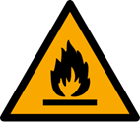  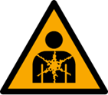  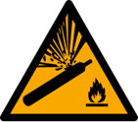
 |  |  |  | ENTRY REQUIREMENTS
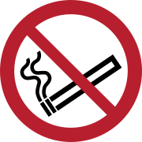



ADDITIONAL SAFETY INFORMATION

- Unauthorized personnel and guests must be given a safety brief by paint shop personnel prior to entering.

POINT OF CONTACT LIST

Name | Title |  |  | Work Phone | After Hours Phone
Mohammed A. | Shop Supervisor
James B. | Painter
Quinten T. | Fire Warden
Arnold S. | Safety Officer
Operations
FIRE
MEDICAL (SAB Clinic)

Signal Word
Authorized Personnel Only
Command: |  | Building: | Room#: |  |  | Date:
PRIMARY TASKS

CHEMICAL HAZARDS |  |  |  | OTHER HAZARDS
 |  |  |  | ENTRY REQUIREMENTS
ADDITOINAL SAFETY INFORMATION

POINT OF CONTACT LIST

Name | Title |  |  | Work Phone | After Hours Phone
 | Fire Warden
 | Safety Officer
Operations
FIRE
MEDICAL (Clinic)

